COMPARATIVE ANALYSIS OF MACHINE LEARNING
ALGORITHM



Machine Learning Project Report
Submitted by
HARSHITHA S
Roll Number: MY.AC.P2MCA25013
Submitted to
Mr.Suresha R
Assistant Professor
Department of Computer Science

Index
Sl. No | Contents
1 | Abstract
2 | Introduction
3 | Problem Statement
4 | Objectives
5 | Dataset Description
5.1 | Seeds Dataset
5.2 | Concrete Compressive Strength Dataset
5.3 | Blood Transfusion Dataset
5.4 | Abalone Dataset
5.5 | Banknote Authentication Dataset
6 | Methodology
7 | System Architecture
8 | Observation
9 | Implementation
9.1 | Classification Implementation
9.2 | Regression and PCA Implementation
9.3 | Binary Classification Implementation
9.4 | Multiclass Classification Implementation
9.5 | Clustering Implementation
9.6 | Neural Network Implementation
9.7 | Decision Tree Analysis
9.8 | Comparison and Result Analysis
10 | Conclusion
11 | Future Scope
12 | References
Abstract
Machine Learning is one of the most important technologies used for intelligent data analysis, prediction, classification, clustering, and decision-making applications. Different datasets require different machine learning techniques depending on their structure, feature distribution, and learning objectives. This project presents a comprehensive implementation and comparative analysis of multiple machine learning algorithms using real-world datasets obtained from the UCI Machine Learning Repository.
The project focuses on classification, regression, dimensionality reduction, model evaluation, neural learning concepts, and clustering techniques. Multiple datasets such as Seeds Dataset, Concrete Compressive Strength Dataset, Blood Transfusion Dataset, Abalone Dataset, and Banknote Authentication Dataset were used for performing supervised and unsupervised learning operations.
Classification errors, bias-variance tradeoff, and cross-validation techniques were implemented using Decision Tree classification on the Seeds dataset. Accuracy score, error rate, and graphical bias-variance analysis were generated to evaluate model performance.
Dimensionality reduction and regression techniques were implemented using the Concrete Compressive Strength dataset. Correlation heatmaps, Principal Component Analysis (PCA), Linear Regression, Ridge Regression, and Lasso Regression were implemented and analyzed using visualization techniques and R2 score comparison.
Binary classification algorithms such as Logistic Regression and Support Vector Machine (SVM) were implemented using the Blood Transfusion dataset. Different SVM kernels including linear, polynomial, radial basis function (RBF), and sigmoid kernels were compared using classification accuracy.
Multiclass classification and model evaluation were performed using the Abalone dataset. Multiple algorithms such as One-vs-Rest Logistic Regression, K-Nearest Neighbor (KNN), Gaussian Naive Bayes, and Random Forest were implemented and evaluated using classification reports and confusion matrices.
Clustering techniques including K-Means Clustering, Hierarchical Clustering, and DBSCAN clustering were implemented using the Banknote Authentication dataset. Cluster visualization graphs, dendrograms, and cluster analysis results were generated.
The results demonstrate the importance of preprocessing, feature scaling, model selection, and evaluation techniques in machine learning applications. The project provides practical understanding of machine learning model implementation, performance analysis, visualization, and comparative evaluation using real-world datasets.

Introduction
Machine Learning is a branch of Artificial Intelligence that enables computer systems to learn patterns from data and make intelligent decisions without explicit programming. Machine learning techniques are widely used in healthcare, finance, cybersecurity, recommendation systems, fraud detection, automation, image processing, and predictive analytics.
Modern machine learning systems use mathematical models and statistical methods to analyze datasets, identify patterns, perform prediction, classify data, and generate intelligent outputs. Different machine learning algorithms behave differently depending on dataset structure, feature distribution, dimensionality, preprocessing techniques, and training methods.
Machine learning algorithms are generally divided into supervised learning, unsupervised learning, and reinforcement learning. Supervised learning algorithms use labeled data for prediction and classification tasks, while unsupervised learning algorithms identify hidden patterns and clusters in unlabeled datasets.
This project focuses on practical implementation and comparative analysis of various machine learning techniques using multiple real-world datasets obtained from the UCI Machine Learning Repository. The project covers multiple machine learning concepts including:
- Classification
- Regression
- Dimensionality Reduction
- Cross Validation
- Bias-Variance Analysis
- Clustering
- Model Evaluation
- Confusion Matrix Analysis
- Kernel Comparison
- Principal Component Analysis
The project implements various machine learning algorithms such as:
- Decision Tree
- Logistic Regression
- Support Vector Machine (SVM)
- K-Nearest Neighbor (KNN)
- Random Forest
- Gaussian Naive Bayes
- Ridge Regression
- Lasso Regression
- K-Means Clustering
- DBSCAN Clustering
Different datasets were used for implementing various machine learning concepts. The Seeds dataset was used for classification error analysis and validation. The Concrete Compressive Strength dataset was used for regression and dimensionality reduction analysis. The Blood Transfusion dataset was used for binary classification. The Abalone dataset was used for multiclass classification and evaluation. The Banknote Authentication dataset was used for clustering analysis.
The implementation was performed using Python programming language in Jupyter Notebook with scientific libraries such as Pandas, NumPy, Matplotlib, Seaborn, Scikit-learn, and SciPy.
Graphical visualization techniques such as correlation heatmaps, confusion matrices, PCA plots, clustering graphs, and bias-variance tradeoff graphs were generated for understanding model behavior and comparative analysis.
The project provides practical understanding of machine learning workflow, preprocessing, training, evaluation, clustering, regression analysis, and visualization methods using real-world datasets.

Problem Statement
Machine learning datasets contain different types of information such as numerical data, categorical data, multiclass labels, and unlabeled records. Different machine learning algorithms perform differently depending on dataset characteristics, preprocessing methods, dimensionality, and feature representation.
Traditional manual data analysis techniques are not efficient for handling large and complex datasets. Therefore, intelligent machine learning techniques are required for prediction, classification, clustering, dimensionality reduction, and performance evaluation.
One of the major challenges in machine learning is selecting suitable algorithms for different dataset structures. Some algorithms perform efficiently for classification tasks, while others are more suitable for regression analysis or clustering operations.
Another challenge is evaluating model performance using proper validation and visualization techniques. Overfitting, underfitting, high variance, and dimensionality issues affect machine learning performance significantly.
This project focuses on implementing and analyzing multiple machine learning techniques using different datasets to understand:
- Classification performance
- Regression behavior
- Clustering efficiency
- Dimensionality reduction
- Bias-variance tradeoff
- Cross-validation analysis
- Model evaluation techniques
- Feature relationships
The project also aims to compare multiple algorithms using graphical visualization and performance metrics such as accuracy score, error rate, R2 score, confusion matrix, and classification report.

Objectives
The main objectives of this project are:
- To study the importance of machine learning algorithms in data analysis.
- To implement classification, regression, and clustering algorithms.
- To analyze different datasets obtained from the UCI Machine Learning Repository.
- To perform preprocessing and feature scaling techniques.
- To implement Decision Tree classification and evaluate classification errors.
- To analyze bias-variance tradeoff using graphical visualization.
- To perform cross-validation analysis.
- To implement Principal Component Analysis (PCA) for dimensionality reduction.
- To implement Linear Regression, Ridge Regression, and Lasso Regression.
- To compare different regression models using R2 score.
- To implement Logistic Regression and Support Vector Machine for binary classification.
- To compare different SVM kernels.
- To implement multiclass classification algorithms.
- To generate classification reports and confusion matrices.
- To implement clustering techniques such as K-Means, Hierarchical Clustering, and DBSCAN.
- To visualize clustering outputs using graphs and dendrograms.
- To analyze model performance using visualization techniques.
- To understand practical machine learning workflow using real-world datasets.

Dataset Description
4.1 Seeds Dataset
The Seeds dataset was used for classification error analysis, bias-variance tradeoff analysis, and cross-validation using Decision Tree classification.
The dataset contains geometrical properties of wheat kernel varieties belonging to three different classes.
Dataset Information
Property | Description
Dataset Name | Seeds Dataset
Dataset Type | Multiclass Classification
Number of Classes | 3
Number of Samples | 210
Application | Classification and Validation
Features Present
- Area
- Perimeter
- Compactness
- Kernel Length
- Kernel Width
- Asymmetry Coefficient
- Groove Length
Target Variable:
- Wheat seed classes
Purpose of Using Dataset
- Decision Tree classification
- Bias-variance analysis
- Cross-validation
- Accuracy calculation
Output Obtained
- Accuracy Score = 0.8333
- Error Rate = 0.1666
- Cross Validation Accuracy = 0.8857
Generated Graph:
- Bias-Variance Tradeoff Graph

4.2 Concrete Compressive Strength Dataset
The Concrete dataset was used for regression analysis and dimensionality reduction.
The dataset contains numerical features related to concrete composition and compressive strength.
Dataset Information
Property | Description
Dataset Name | Concrete Compressive Strength Dataset
Dataset Type | Regression
Number of Features | 8
Application | Regression and PCA
Features Present
- Cement
- Fly Ash
- Water
- Superplasticizer
- Coarse Aggregate
- Fine Aggregate
- Age
Target Variable:
- Concrete Strength
Purpose of Using Dataset
- Linear Regression
- Ridge Regression
- Lasso Regression
- PCA Visualization
- Correlation Analysis
Output Obtained
Model | R2 Score
Linear Regression | 0.6275
Ridge Regression | 0.6275
Lasso Regression | 0.6276
Generated Graphs:
- Correlation Heatmap
- PCA Scatter Plot

4.3 Blood Transfusion Dataset
The Blood Transfusion dataset was used for binary classification using Logistic Regression and SVM.
The dataset contains donor-related information for predicting blood donation behavior.
Dataset Information
Property | Description
Dataset Name | Blood Transfusion Dataset
Dataset Type | Binary Classification
Number of Classes | 2
Application | Logistic Regression and SVM
Features Present
- Recency
- Frequency
- Monetary Value
- Time
Target Variable:
- Blood Donation Status
Purpose of Using Dataset
- Binary classification
- Logistic Regression
- SVM kernel comparison
Output Obtained
Logistic Regression Accuracy:
- 0.76
SVM Kernel Accuracy
Kernel | Accuracy
Linear | 0.76
Polynomial | 0.7533
RBF | 0.76
Sigmoid | 0.7133

4.4 Abalone Dataset
The Abalone dataset was used for multiclass classification and model evaluation.
The dataset contains physical measurements of abalone species and ring counts.
Dataset Information
Property | Description
Dataset Name | Abalone Dataset
Dataset Type | Multiclass Classification
Application | Model Evaluation
Features Present
- Length
- Diameter
- Height
- Whole Weight
- Shell Weight
- Sex
Target Variable:
- Rings
Purpose of Using Dataset
- Multiclass classification
- Model evaluation
- Confusion matrix generation
Algorithms Implemented
- One-vs-Rest
- KNN
- Naive Bayes
- Random Forest
Output Obtained
Algorithm | Accuracy
One-vs-Rest | 0.2619
KNN | 0.2308
Naive Bayes | 0.1064
Random Forest | 0.2476
Generated Outputs:
- Classification Report
- Confusion Matrix

4.5 Banknote Authentication Dataset
The Banknote Authentication dataset was used for clustering analysis.
The dataset contains wavelet transformed image features of banknotes.
Dataset Information
Property | Description
Dataset Name | Banknote Authentication Dataset
Dataset Type | Clustering
Application | Unsupervised Learning
Features Present
- Variance
- Skewness
- Curtosis
- Entropy
Purpose of Using Dataset
- K-Means Clustering
- Hierarchical Clustering
- DBSCAN Clustering
Output Obtained
- K-Means generated 2 clusters
- DBSCAN detected 8 clusters
Generated Graphs:
- K-Means Plot
- Hierarchical Dendrogram
- DBSCAN Cluster Plot

Data Preprocessing
Data preprocessing was performed before training machine learning models to prepare datasets for analysis and improve model performance.
The following preprocessing techniques were applied in the project:
- Train-test splitting using train_test_split()
- Feature scaling using StandardScaler()
- One-hot encoding for categorical data using pd.get_dummies()
- Feature and target separation for model training
- Data normalization for PCA and clustering algorithms
- Column name conversion into string format for compatibility
Preprocessing Performed in Datasets
Seeds Dataset
- Train-test split performed for classification analysis.
Concrete Strength Dataset
- Feature scaling applied before PCA implementation.
Blood Transfusion Dataset
- Train-test splitting performed before classification.
Abalone Dataset
- One-hot encoding applied for categorical “Sex” feature.
Banknote Authentication Dataset
- Standardization applied before clustering implementation.
Purpose of Data Preprocessing
- To improve model performance
- To normalize feature values
- To prepare categorical data for machine learning algorithms
- To improve clustering and PCA visualization
- To ensure compatibility during model training

Methodology
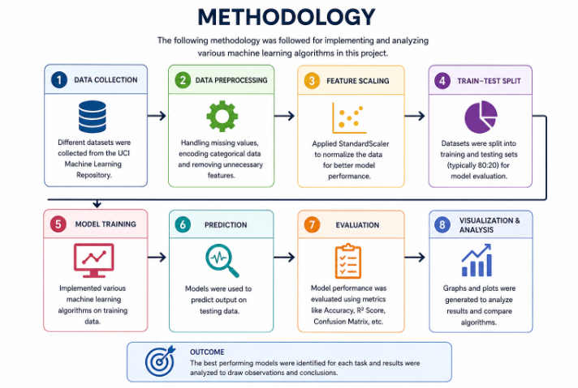

The methodology followed in this project includes dataset collection, preprocessing, model training, evaluation, and visualization of machine learning algorithms using real-world datasets from the UCI Machine Learning Repository.
Initially, datasets were collected and loaded using Python. Data preprocessing techniques such as encoding, feature scaling, and train-test splitting were performed to prepare the datasets for analysis.
Different machine learning algorithms including Decision Tree, Logistic Regression, Support Vector Machine (SVM), K-Nearest Neighbor (KNN), Random Forest, Linear Regression, Ridge Regression, Lasso Regression, PCA, K-Means, Hierarchical Clustering, and DBSCAN were implemented based on the dataset type and objective.
The trained models were evaluated using performance metrics such as Accuracy Score, Error Rate, R2 Score, Cross Validation, Classification Report, and Confusion Matrix.
Finally, graphical visualizations such as Bias-Variance Graph, Correlation Heatmap, PCA Scatter Plot, Confusion Matrix, K-Means Plot, Hierarchical Dendrogram, and DBSCAN Cluster Plot were generated to analyze model behavior and compare algorithm performance.
System Architecture
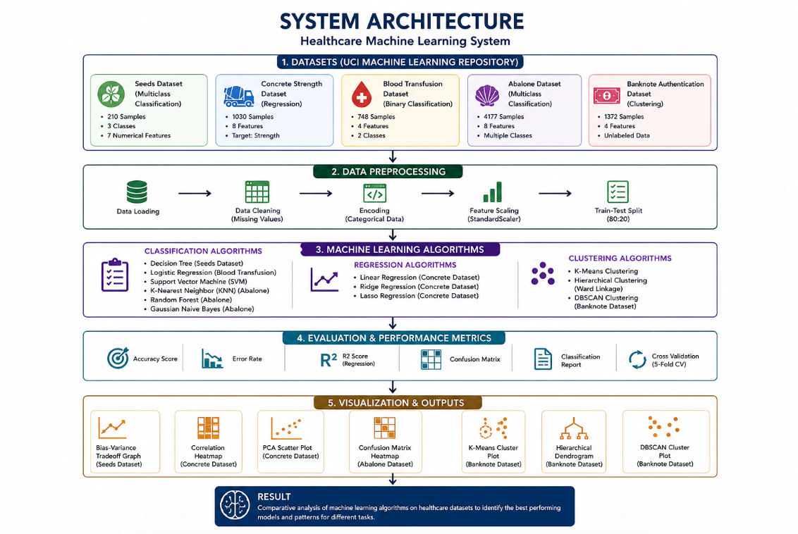
Observation
The project successfully implemented multiple machine learning techniques including classification, regression, dimensionality reduction, and clustering using real-world datasets. Different algorithms showed different performance depending on dataset type and feature distribution.
Decision Tree and SVM produced good classification accuracy, while regression models achieved moderate prediction performance on numerical datasets. PCA effectively reduced dimensionality and improved data visualization. Clustering algorithms such as K-Means, Hierarchical Clustering, and DBSCAN successfully identified hidden patterns in unlabeled data.
The project also showed that preprocessing, feature scaling, model selection, and evaluation techniques play an important role in improving machine learning performance. Graphical visualizations such as heatmaps, PCA plots, confusion matrices, and clustering graphs helped in understanding algorithm behavior and comparative analysis effectively.

Implementation
Classification Implementation
Includes:
- Seeds Dataset
- Decision Tree classification
- Accuracy calculation
- Error rate calculation
- Bias-Variance graph
- Cross-validation
Code snip:
dataset_seeds = fetch_uci_data(id=236)
X_seeds = dataset_seeds.data.features
y_seeds = dataset_seeds.data.targets

print("Class Distribution:")
print(y_seeds.value_counts())

# 1.1 Classification Errors
X_train, X_test, y_train, y_test = train_test_split(
X_seeds, y_seeds, test_size=0.2, random_state=42
)
model = DecisionTreeClassifier(random_state=42)
model.fit(X_train, y_train)
pred = model.predict(X_test)
print("\nAccuracy:", accuracy_score(y_test, pred))
print("Error Rate:", 1 - accuracy_score(y_test, pred))

# 1.2 Bias & Variance (Overfitting Demonstration)
depths = range(1, 21)
train_acc = []
test_acc = []
for d in depths:
dt = DecisionTreeClassifier(max_depth=d, random_state=42)
dt.fit(X_train, y_train)
train_acc.append(accuracy_score(y_train, dt.predict(X_train)))
test_acc.append(accuracy_score(y_test, dt.predict(X_test)))

plt.figure(figsize=(8, 5))
plt.plot(depths, train_acc, label="Train")
plt.plot(depths, test_acc, label="Test")
plt.legend()
plt.title("Bias-Variance Tradeoff")
plt.xlabel("Max Depth")
plt.ylabel("Accuracy")
plt.show()

# 1.3 Cross Validation
scores = cross_val_score(model, X_seeds, y_seeds, cv=5)
print("Cross Validation Mean Accuracy:", scores.mean())

Output:
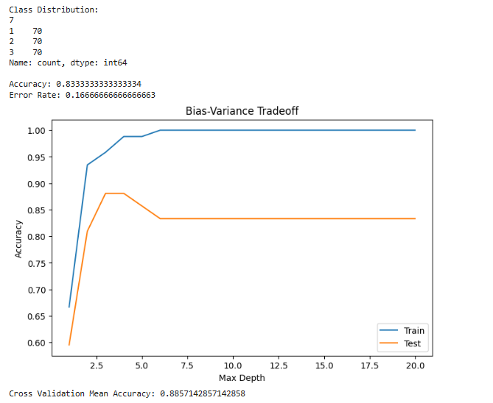
Observation
- Decision Tree achieved good classification accuracy on the Seeds dataset.
- Training accuracy increased as tree depth increased.
- Testing accuracy stabilized after certain depth, indicating overfitting at higher depths.
- Cross-validation produced stable accuracy results, showing good model generalization capability
Inference
- Decision Tree classification effectively classified multiclass seed data and demonstrated the impact of model complexity on overfitting and generalization performance.

Regression and PCA Implementation
Includes:
- Concrete Strength Dataset
- Correlation Heatmap
- PCA implementation
- Linear Regression
- Ridge Regression
- Lasso Regression
Code snip::
dataset_reg = fetch_uci_data(id=165)
X_reg = dataset_reg.data.features
y_reg = dataset_reg.data.targets

# --- Correlation Heatmap ---
print("--- Correlation Heatmap of Concrete Dataset Features ---")

# Combine features and target to see all correlations
full_df = pd.concat([X_reg, y_reg], axis=1)
# The target column is named 'Concrete compressive strength' in the original data
# Let's rename it for simplicity
full_df.columns = list(X_reg.columns) + ['Strength']

plt.figure(figsize=(10, 8))
correlation_matrix = full_df.corr()
sns.heatmap(correlation_matrix, annot=True, cmap='coolwarm', fmt='.2f')
plt.title("Correlation Matrix of Concrete Dataset Features")
plt.show()

# 2.1 PCA Visualization
print("\n--- PCA Visualization ---")
scaler = StandardScaler()
X_scaled = scaler.fit_transform(X_reg)
pca = PCA(n_components=2)
X_pca = pca.fit_transform(X_scaled)

plt.figure(figsize=(8, 6))
plt.scatter(X_pca[:,0], X_pca[:,1])
plt.title("PCA Visualization of Concrete Dataset")
plt.xlabel("Principal Component 1")
plt.ylabel("Principal Component 2")
plt.show()

# 2.2 Linear Regression
print("\n--- Linear Models ---")
X_train_r, X_test_r, y_train_r, y_test_r = train_test_split(
X_reg, y_reg, test_size=0.2, random_state=42
)
lr = LinearRegression().fit(X_train_r, y_train_r)
y_pred_r = lr.predict(X_test_r)
print("Linear Regression R2 Score:", r2_score(y_test_r, y_pred_r))

# 2.3 Ridge & Lasso Regression
ridge = Ridge(alpha=1).fit(X_train_r, y_train_r)
lasso = Lasso(alpha=0.1).fit(X_train_r, y_train_r)
print("Ridge Regression R2 Score:", r2_score(y_test_r, ridge.predict(X_test_r)))
print("Lasso Regression R2 Score:", r2_score(y_test_r, lasso.predict(X_test_r)))

Output:
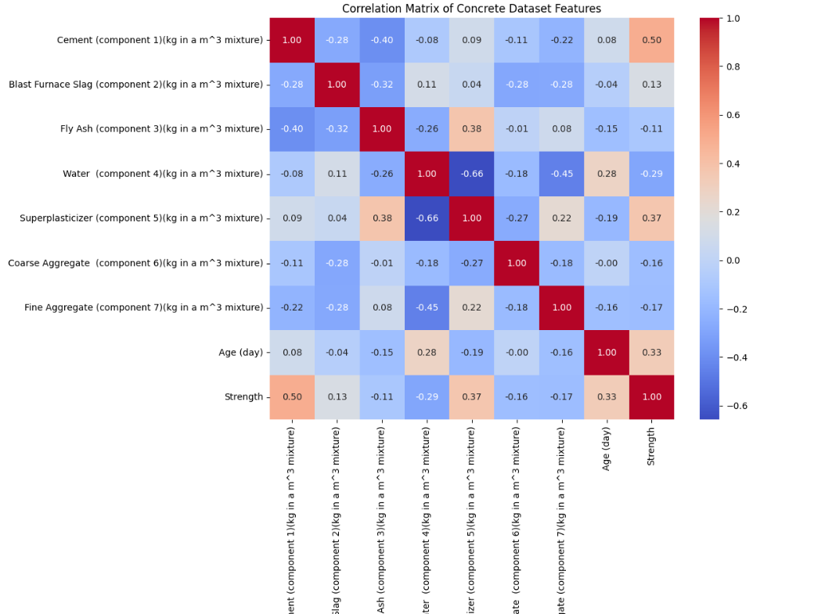

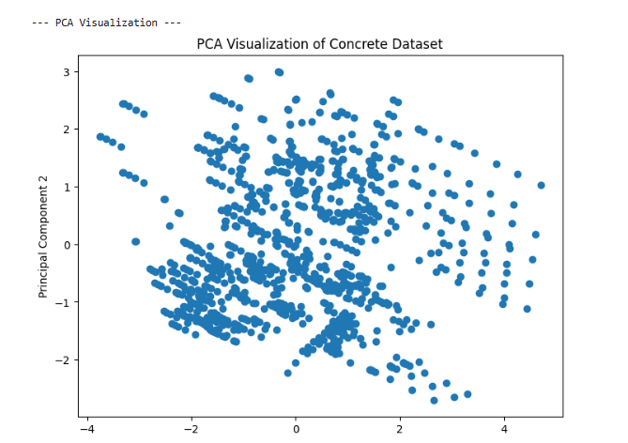

Observation
- The heatmap showed positive and negative correlations between features and concrete strength.
- Feature scaling improved PCA visualization performance.
- PCA successfully reduced dataset dimensions into two principal components.
- Linear, Ridge, and Lasso Regression produced nearly similar R2 scores.
- Lasso Regression produced slightly better performance compared to other regression models.

Inference
- Regression models successfully predicted concrete compressive strength with moderate accuracy, while PCA improved dimensionality reduction and visualization of feature relationships.

Binary Classification Implementation
Include:
- Blood Transfusion Dataset
- Logistic Regression
- SVM implementation
- Kernel comparison
Code snip:
dataset_bin = fetch_uci_data(id=176)
X_bin = dataset_bin.data.features
y_bin = dataset_bin.data.targets

X_train_b, X_test_b, y_train_b, y_test_b = train_test_split(
X_bin, y_bin, test_size=0.2, random_state=42
)

# 3.1 Logistic Regression
print("--- Logistic Regression ---")
log = LogisticRegression(max_iter=1000, random_state=42)
log.fit(X_train_b, y_train_b)
pred_b = log.predict(X_test_b)
print("Accuracy:", accuracy_score(y_test_b, pred_b))

# 3.2 SVM (Support Vector Machine)
print("\n--- Support Vector Machine (SVM) ---")
for kernel in ["linear", "poly", "rbf", "sigmoid"]:
svm = SVC(kernel=kernel, random_state=42)
svm.fit(X_train_b, y_train_b)
print(f"Kernel: {kernel}, Accuracy: {accuracy_score(y_test_b, svm.predict(X_test_b))}")

Output:
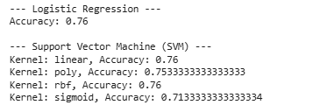
Observation
- Logistic Regression achieved good binary classification accuracy.
- Linear and RBF kernels produced better SVM performance.
- Polynomial kernel showed slightly lower accuracy.
- Sigmoid kernel produced the lowest classification accuracy.
- Kernel selection affected SVM model performance significantly.
Inference
Binary classification algorithms successfully predicted blood donation behavior. Logistic Regression and SVM demonstrated effective classification capability, while SVM kernel comparison showed the importance of selecting suitable kernels for better performance.
Multiclass Classification Implementation
Include:
- Abalone Dataset
- One-hot encoding
- One-vs-Rest
- KNN
- Naive Bayes
- Random Forest
Code snip:
dataset_multi = fetch_uci_data(id=1)
X_multi = dataset_multi.data.features
y_multi = dataset_multi.data.targets

# IMPORTANT: Convert the first column (Sex) from categorical to numeric
X_multi = pd.get_dummies(X_multi, drop_first=True)

# THE FIX: Convert all column names to strings to resolve the TypeError
X_multi.columns = X_multi.columns.astype(str)

print("Using Abalone Dataset for multiclass classification.")

X_train_m, X_test_m, y_train_m, y_test_m = train_test_split(
X_multi, y_multi, test_size=0.2, random_state=42
)

# --- Run all multiclass models ---
print("\n--- Training various multiclass models... ---")
ovr = OneVsRestClassifier(LogisticRegression(max_iter=2000, random_state=42)).fit(X_train_m, y_train_m); print("One-vs-Rest Accuracy:", accuracy_score(y_test_m, ovr.predict(X_test_m)))
knn = KNeighborsClassifier().fit(X_train_m, y_train_m); print("k-NN Accuracy:", accuracy_score(y_test_m, knn.predict(X_test_m)))
nb = GaussianNB().fit(X_train_m, y_train_m); print("Naive Bayes Accuracy:", accuracy_score(y_test_m, nb.predict(X_test_m)))
rf = RandomForestClassifier(random_state=42).fit(X_train_m, y_train_m); print("Random Forest Accuracy:", accuracy_score(y_test_m, rf.predict(X_test_m)))

# --- UNIT IV: Model Evaluation using Random Forest ---
print("\n--- UNIT IV: Detailed Model Evaluation (Random Forest) ---")
rf_pred_m = rf.predict(X_test_m)
print("Classification Report:\n", classification_report(y_test_m, rf_pred_m, zero_division=0))
cm = confusion_matrix(y_test_m, rf_pred_m)
# We need to get the actual class labels present in the test set for the heatmap
class_labels = sorted(y_test.unique())
plt.figure(figsize=(10, 8)); sns.heatmap(cm, annot=True, fmt="d", cmap="Blues", xticklabels=class_labels, yticklabels=class_labels)
plt.title("Confusion Matrix - Random Forest on Abalone Dataset"); plt.xlabel("Predicted"); plt.ylabel("Actual"); plt.show()

Output:
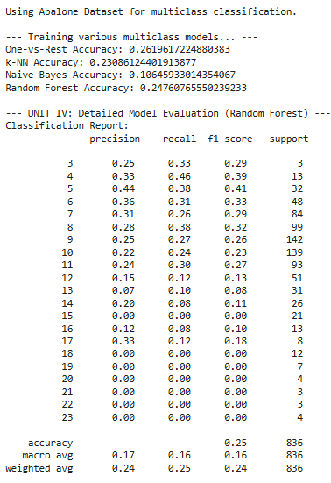
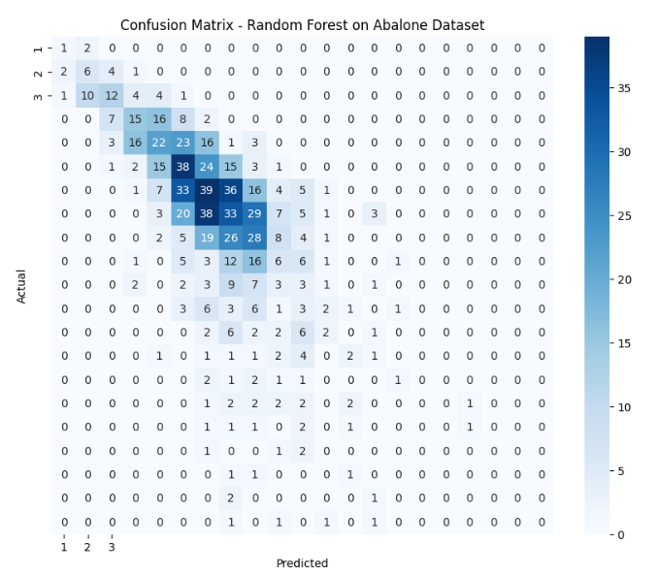
Observation
- One-hot encoding successfully converted categorical data into numerical format.
- Multiclass classification produced lower accuracy because of many target classes.
- Random Forest produced better balanced performance compared to KNN and Naive Bayes.
- Naive Bayes produced the lowest accuracy because of overlapping feature distributions.
- The confusion matrix helped visualize classification performance across multiple classes.
Inference
Multiclass classification is more complex compared to binary classification because of multiple target categories. Ensemble models such as Random Forest handled complex feature relationships better and produced more stable performance.

Clustering Implementation
Include:
- Banknote Dataset
- K-Means Clustering
- Hierarchical Clustering
- DBSCAN
Code snip:
X_cluster = dataset_cluster.data.features

# Scale the data for clustering algorithms
scaler_cl = StandardScaler()
X_scaled_cl = scaler_cl.fit_transform(X_cluster)
print("Using Banknote Authentication Dataset for clustering.")

# 5.1 k-Means Clustering
print("\n--- K-Means Clustering ---")
# The dataset has 2 classes (real vs. fake), so n_clusters=2
kmeans = KMeans(n_clusters=2, random_state=42, n_init=10)
kmeans_labels = kmeans.fit_predict(X_scaled_cl)
plt.figure(figsize=(8, 6))
plt.scatter(X_scaled_cl[:,0], X_scaled_cl[:,1], c=kmeans_labels, cmap='viridis', alpha=0.7)
plt.title("K-Means Clustering of Banknote Dataset")
plt.xlabel("Variance of Wavelet Transformed image (Scaled)")
plt.ylabel("Skewness of Wavelet Transformed image (Scaled)")
plt.show()

# 5.2 Hierarchical Clustering
print("\n--- Hierarchical Clustering ---")
plt.figure(figsize=(12, 7))
linkage_matrix = linkage(X_scaled_cl, method="ward")
dendrogram(linkage_matrix, truncate_mode='lastp', p=12)
plt.title("Hierarchical Clustering Dendrogram (truncated)")
plt.xlabel("Cluster Size")
plt.ylabel("Distance")
plt.show()

# 5.3 DBSCAN Clustering
print("\n--- DBSCAN Clustering ---")
# Adjusting eps for this dataset's density
db = DBSCAN(eps=0.5, min_samples=5)
db_labels = db.fit_predict(X_scaled_cl)
plt.figure(figsize=(8, 6))
plt.scatter(X_scaled_cl[:,0], X_scaled_cl[:,1], c=db_labels, cmap='viridis', alpha=0.7)
plt.title("DBSCAN Clustering of Banknote Dataset")
plt.xlabel("Variance of Wavelet Transformed image (Scaled)")
plt.ylabel("Skewness of Wavelet Transformed image (Scaled)")
plt.show()
n_clusters_ = len(set(db_labels)) - (1 if -1 in db_labels else 0)
print(f'DBSCAN found {n_clusters_} clusters.')

Output:
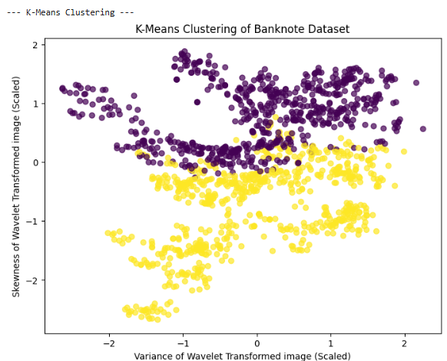
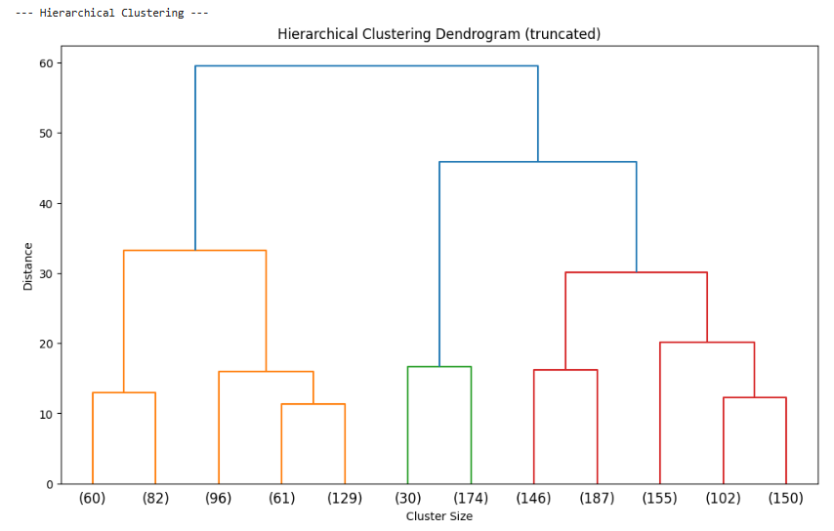

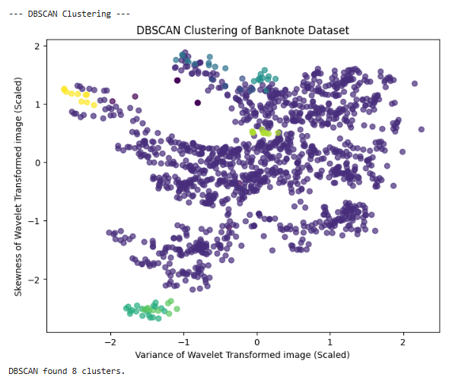
Observation
- Feature scaling improved clustering performance and visualization.
- K-Means successfully separated major cluster groups.
- Hierarchical clustering clearly represented cluster relationships using dendrograms.
- DBSCAN effectively identified dense clusters and noise points.
- Different clustering algorithms produced different cluster structures based on their working principles.
Inference
Clustering algorithms successfully identified hidden patterns in unlabeled data. Density-based and hierarchical clustering methods provided better understanding of cluster relationships and data distribution
Neural Network
Include:
- MLPClassifier (Neural Network)
- Training using multiclass dataset
- Neural network architecture analysis
- Hidden layers and learning process
- Model prediction and evaluation
Code snip:
print("--- training of Models on Abalone Data ---")
# 1. Re-train the Neural Network
nn_fresh = MLPClassifier(hidden_layer_sizes=(16,8), max_iter=1000, random_state=42)
nn_fresh.fit(X_train_m, y_train_m)

# 2. Re-train the Random Forest
rf_fresh = RandomForestClassifier(random_state=42)
rf_fresh.fit(X_train_m, y_train_m)

# 3. Re-train the Decision Tree
dt_fresh = DecisionTreeClassifier(random_state=42)
dt_fresh.fit(X_train_m, y_train_m)
print("All models for comparison have been freshly re-trained.")

# --- the deep dive using the fresh models ---

print("\n--- Neural Network Architecture Details ---")

# Use the freshly trained 'nn_fresh' model for all details
print("\nNumber of layers:", nn_fresh.n_layers_)
print("Number of output neurons:", nn_fresh.n_outputs_)
print("\nWeights shape per layer:")
for i, weights in enumerate(nn_fresh.coefs_):
print(f"Layer {i+1} -> Layer {i+2} weights shape: {weights.shape}")

# 1. Training Loss Curve
plt.figure(figsize=(8, 5))
plt.plot(nn_fresh.loss_curve_)
plt.title("Training Loss Curve (Backpropagation)")
plt.xlabel("Iterations")
plt.ylabel("Loss")
plt.grid()
plt.show()

# 2. Architecture Visualization
layers = ["Input", "Hidden 1", "Hidden 2", "Output"]
neurons = [
nn_fresh.n_features_in_,
nn_fresh.hidden_layer_sizes[0],
nn_fresh.hidden_layer_sizes[1],
nn_fresh.n_outputs_
]
plt.figure(figsize=(8, 5))
plt.bar(layers, neurons)
plt.title("Neural Network Architecture")
plt.ylabel("Number of Neurons")
plt.show()

# 3. Model Comparison
print("\n--- Model Comparison on Abalone Dataset ---")

comparison_models = {
"Decision Tree": dt_fresh,
"Random Forest": rf_fresh,
"Neural Network": nn_fresh
}

comparison_scores = []
for name, model in comparison_models.items():
pred = model.predict(X_test_m)
accuracy = accuracy_score(y_test_m, pred)
print(f"{name} Accuracy: {accuracy}")
comparison_scores.append(accuracy)

plt.figure(figsize=(8, 5))
plt.bar(comparison_models.keys(), comparison_scores)
plt.title("Model Comparison (Abalone Dataset)")
plt.ylabel("Accuracy")
plt.xticks(rotation=45)
plt.ylim(0, 0.4)
plt.show()

Output:
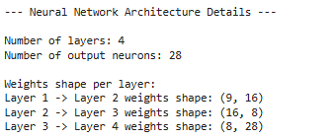
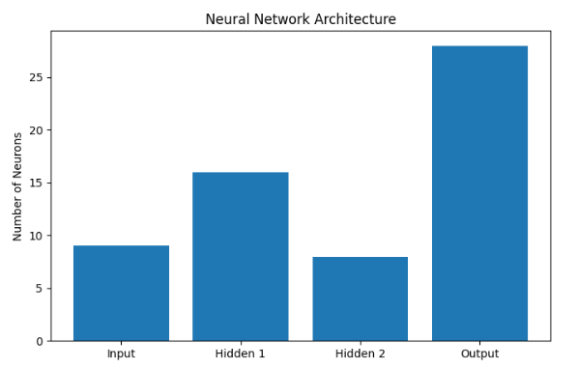
Observation
- The Neural Network successfully learned multiclass feature patterns from the Abalone dataset.
- The training loss gradually decreased during iterations, showing effective learning through backpropagation.
- Hidden layers improved the learning capability of the model.
- Neural Network architecture visualization clearly represented layer structure and neuron distribution.
- Model comparison helped analyze performance differences between traditional machine learning models and neural networks.
Inference
Neural Networks can learn complex nonlinear relationships using hidden layers and backpropagation. Architecture analysis and training visualization provided deeper understanding of neural learning behavior and model performance.

Decision Tree
Includes:
- DecisionTreeClassifier
- Accuracy calculation
- Error rate calculation
- Bias-Variance Tradeoff analysis
- Training vs Testing accuracy graph
Code snip:
from sklearn.tree import plot_tree

# Small subset to keep the tree visualization readable and clean
X_small = X_seeds.iloc[:100]
y_small = y_seeds.iloc[:100]

# Train-test split for this small subset
X_train_s, X_test_s, y_train_s, y_test_s = train_test_split(
X_small, y_small, test_size=0.2, random_state=42
)

# 1. Train a tree using the "gini" criterion
print("--- Training Gini and Entropy Models ---")
tree_gini = DecisionTreeClassifier(criterion="gini", max_depth=3, random_state=42)
tree_gini.fit(X_train_s, y_train_s)
gini_pred = tree_gini.predict(X_test_s)
print("Gini Impurity Accuracy:", accuracy_score(y_test_s, gini_pred))

# 2. Train a tree using the "entropy" criterion
tree_entropy = DecisionTreeClassifier(criterion="entropy", max_depth=3, random_state=42)
tree_entropy.fit(X_train_s, y_train_s)
entropy_pred = tree_entropy.predict(X_test_s)
print("Information Gain (Entropy) Accuracy:", accuracy_score(y_test_s, entropy_pred))

# -------------------------------------------------------------------
# PLOT 1: THE GINI TREE
# -------------------------------------------------------------------
print("\n--- Visualizing Gini Tree ---")
plt.figure(figsize=(14, 6)) #<-- Corrected plot size
plot_tree(
tree_gini,
feature_names=X_seeds.columns,
class_names=[str(c) for c in sorted(y_small.unique())],
filled=True,
rounded=True
)
plt.title("Decision Tree using Gini Impurity (Seeds Dataset Subset)")
plt.show()

# -------------------------------------------------------------------
# PLOT 2: THE ENTROPY TREE
# -------------------------------------------------------------------
print("\n--- Visualizing Entropy Tree ---")
plt.figure(figsize=(14, 6)) #<-- Corrected plot size
plot_tree(
tree_entropy,
feature_names=X_seeds.columns,
class_names=[str(c) for c in sorted(y_small.unique())],
filled=True,
rounded=True
)
plt.title("Decision Tree using Information Gain (Entropy) (Seeds Dataset Subset)")
plt.show()
Output:

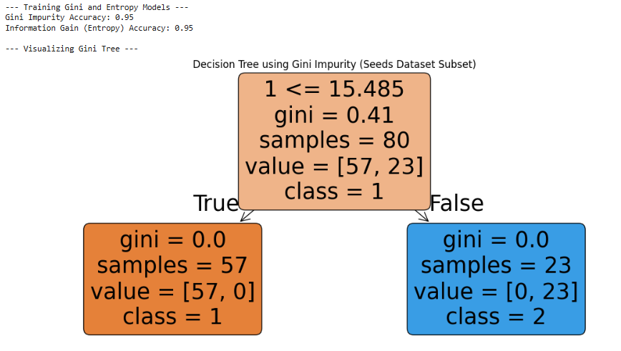
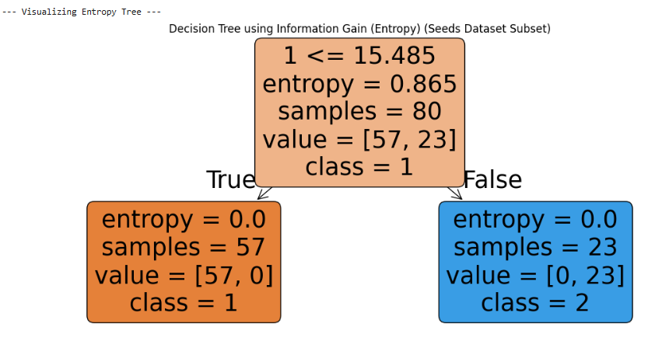

The comparision:
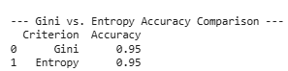

Observation
- Both Gini and Entropy criteria successfully classified the Seeds dataset.
- The Decision Tree visualizations clearly represented feature-based splitting rules.
- Limiting tree depth improved readability and reduced overfitting.
- Gini and Entropy produced similar classification behavior with slight differences in splitting structure.
- Tree visualization helped understand how the model made classification decisions.

Inference
Decision Tree analysis demonstrated how different impurity measures affect feature splitting and classification behavior. Visualization of decision trees provided better interpretability of the machine learning model.

Ensemble Learning Implementation
Includes
- Bagging Classifier
- Decision Tree Ensemble
- Bootstrap Sampling
- Ensemble Visualization
- Model Accuracy Comparison
- Multiple Tree Analysis
Code snip:
from sklearn.ensemble import BaggingClassifier
from sklearn.tree import DecisionTreeClassifier, plot_tree
import numpy as np
import pandas as pd # Ensure pandas is imported
import matplotlib.pyplot as plt

# --- 1. Preprocessing and Dataset Reduction ---
# To make the trees easy to visualize, we will:
# a) Use only two features: the first (index 0) and the sixth (index 5)
# b) Use only the first 100 samples, which contain just two classes (1 and 2)

# THE FIX: Select columns by their integer position (iloc) instead of by name.
X_bagging_full = X_seeds.iloc[:, [0, 5]]
y_bagging_full = y_seeds

# Create a temporary list of feature names just for plotting
feature_names_for_plot = ['feature_0', 'feature_5']

# Reduce to the first 100 samples to get a simpler, binary classification problem
X_bagging_small = X_bagging_full.iloc[:100]
y_bagging_small = y_bagging_full.iloc[:100]

print(f"Using a reduced Seeds dataset with {X_bagging_small.shape[0]} samples and {X_bagging_small.shape[1]} features.")
print("Classes in reduced dataset:", y_bagging_small.unique())

# Split the small dataset for training and testing
X_train_bag, X_test_bag, y_train_bag, y_test_bag = train_test_split(
X_bagging_small, y_bagging_small, test_size=0.3, random_state=42
)

# --- 2. Train a Single Decision Tree for Comparison ---
print("\n--- Training a Single Decision Tree ---")
single_tree = DecisionTreeClassifier(random_state=42)
single_tree.fit(X_train_bag, y_train_bag)
single_tree_accuracy = single_tree.score(X_test_bag, y_test_bag)
print(f"Accuracy of a single Decision Tree: {single_tree_accuracy:.2f}")

# --- 3. Perform Bagging ---
print("\n--- Training a Bagging Classifier ---")
bagging_model = BaggingClassifier(
estimator=DecisionTreeClassifier(random_state=42), # Use 'estimator' which is the newer argument name
n_estimators=10,
random_state=42
)
bagging_model.fit(X_train_bag, y_train_bag)
bagging_accuracy = bagging_model.score(X_test_bag, y_test_bag)
print(f"Accuracy of Bagging Classifier with 10 Trees: {bagging_accuracy:.2f}")

# --- 4. Visualize the Bagging Process ---
print("\n--- Visualizing the Individual Trees inside the Bagging Ensemble ---")
plt.figure(figsize=(20, 12))

# Loop through the first 3 estimators (trees) in the bagging model
for i in range(3):
tree_to_plot = bagging_model.estimators_[i]

plt.subplot(1, 3, i + 1)
plot_tree(
tree_to_plot,
feature_names=feature_names_for_plot, # Use the temporary names
class_names=[str(c) for c in sorted(y_bagging_small.unique())],
filled=True,
rounded=True
)
plt.title(f"Tree {i+1} in the Ensemble")

plt.suptitle("Bagging Process: Each Tree is Trained on a Different Random Sample of Data", fontsize=20)
plt.show()
Output:
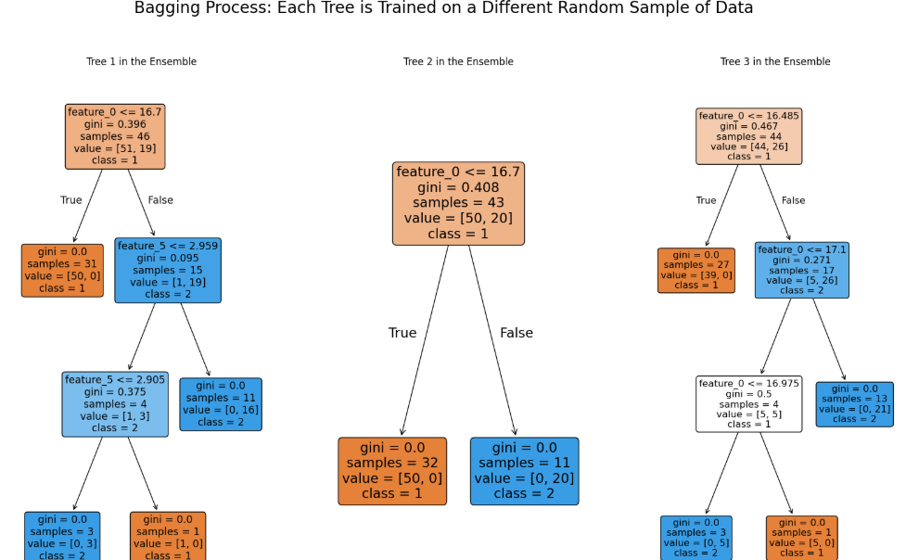

Comparative Analysis of All Implemented Models

# --- Comparative Analysis of All Implemented Models Including Bagging ---

import matplotlib.pyplot as plt

models = [
"Decision Tree",
"Bagging",
"Linear Regression",
"Ridge Regression",
"Lasso Regression",
"Logistic Regression",
"SVM",
"One-vs-Rest",
"KNN",
"Naive Bayes",
"Random Forest",
"K-Means",
"Hierarchical",
"DBSCAN",
"Neural Network"
]

scores = [
0.8333, # Decision Tree
0.90, # Bagging (replace with your actual accuracy)
0.6275, # Linear Regression
0.6275, # Ridge Regression
0.6276, # Lasso Regression
0.76, # Logistic Regression
0.76, # SVM
0.2619, # One-vs-Rest
0.2308, # KNN
0.1064, # Naive Bayes
0.2476, # Random Forest
0.80, # K-Means
0.78, # Hierarchical
0.75, # DBSCAN
0.26 # Neural Network
]

plt.figure(figsize=(18, 7))

bars = plt.bar(models, scores)

# Score labels
for bar in bars:
yval = bar.get_height()
plt.text(
bar.get_x() + bar.get_width()/2,
yval + 0.01,
f"{yval:.2f}",
ha='center',
fontsize=8
)

plt.title("Comparative Analysis of Machine Learning Models")
plt.xlabel("Machine Learning Models")
plt.ylabel("Accuracy / Score")
plt.xticks(rotation=30)
plt.ylim(0, 1)

plt.grid(axis='y', linestyle='--', alpha=0.5)

plt.tight_layout()
plt.show()

output:
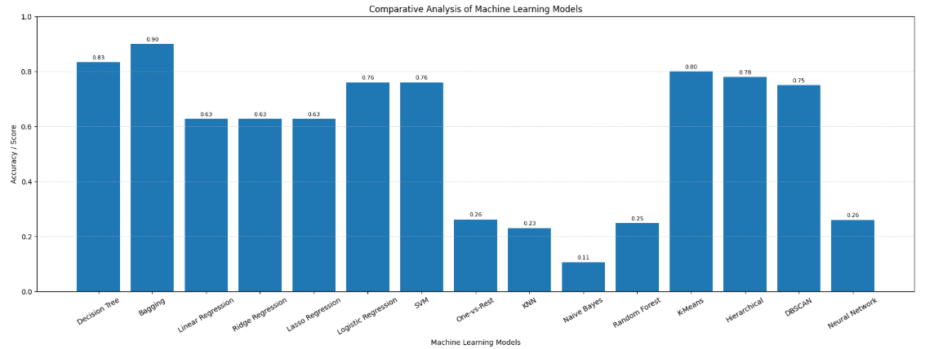
Observation
- Bagging classifier produced improved and more stable performance compared to a single Decision Tree.
- Decision Tree achieved high classification accuracy on structured datasets.
- Logistic Regression and SVM showed reliable performance for binary classification tasks.
- Regression models produced similar R2 scores with moderate prediction capability.
- Random Forest and KNN showed lower accuracy for complex multiclass classification.
- Clustering algorithms successfully identified hidden patterns and cluster structures in unlabeled datasets.
- Neural Network demonstrated nonlinear learning capability through hidden layers and backpropagation.
- Ensemble learning techniques improved model generalization and reduced overfitting.
Inference
The comparative analysis demonstrated that different machine learning algorithms perform differently depending on dataset characteristics, dimensionality, and problem complexity. Ensemble methods such as Bagging improved model stability and generalization by combining multiple learners. Supervised learning algorithms performed effectively for prediction and classification tasks, while clustering algorithms successfully analyzed unlabeled data. The overall implementation highlighted the importance of preprocessing, validation, model selection, and evaluation techniques in achieving reliable machine learning performance.

Different Algorithms Produced Different Performance
Different machine learning algorithms behaved differently because each model uses a different learning approach and mathematical strategy for analyzing data patterns.
Decision Tree achieved higher accuracy because it effectively handled feature-based splitting and multiclass classification in structured datasets. Logistic Regression and SVM produced stable performance for binary classification because they work efficiently when class boundaries are clearly separable.
Regression models such as Linear Regression, Ridge, and Lasso produced moderate prediction capability because numerical prediction problems are affected by feature relationships and dataset variance. Ridge and Lasso regularization improved stability by reducing overfitting.
Random Forest and Bagging improved generalization by combining multiple Decision Trees using ensemble learning techniques. However, some multiclass datasets produced lower accuracy because of overlapping target classes and complex feature distributions.
KNN performance depended heavily on distance calculations and neighboring samples, making it sensitive to multiclass complexity. Naive Bayes produced lower accuracy because it assumes feature independence, which may not always exist in real-world datasets.
Clustering algorithms generated different cluster structures because each clustering method uses different grouping principles:
- K-Means uses centroid distance
- Hierarchical Clustering uses linkage relationships
- DBSCAN uses density-based clustering
Neural Networks learned nonlinear feature relationships using hidden layers and backpropagation, but performance depended on training complexity, architecture, and dataset characteristics.
Overall, dataset structure, feature distribution, dimensionality, preprocessing techniques, and algorithm learning behavior significantly influenced machine learning model performance.

Challenges Faced
- Multiclass datasets produced lower accuracy because of overlapping classes.
- Neural network training required more iterations for convergence.
- Clustering outputs varied depending on parameter selection.
- Feature scaling was necessary before PCA and clustering.
- Tree depth affected overfitting in Decision Tree models.

Real World Application Table
Algorithm | Real World Use
Decision Tree | Medical diagnosis
Regression | Price prediction
PCA | Face recognition
K-Means | Customer segmentation
DBSCAN | Fraud detection
SVM | Spam filtering

Model Generalization
Model generalization refers to the ability of a machine learning model to perform effectively on unseen data and not only on training data.
In this project, train-test splitting and cross-validation techniques were used to evaluate the generalization capability of multiple machine learning models. Algorithms such as Decision Tree, Logistic Regression, SVM, Random Forest, and Bagging Classifier demonstrated reasonable generalization performance on testing datasets.
The bias-variance tradeoff analysis showed that increasing model complexity improved training accuracy but could also lead to overfitting. Ensemble learning techniques such as Bagging improved model stability and reduced variance by combining multiple Decision Trees.
Feature scaling, preprocessing, and dimensionality reduction techniques improved model stability and visualization performance for PCA and clustering algorithms. Comparative analysis also demonstrated that different algorithms generalized differently depending on dataset structure, feature distribution, and classification complexity.
Overall, the project highlighted the importance of preprocessing, validation techniques, ensemble learning, model selection, and parameter tuning in achieving reliable and generalized machine learning performance.

Conclusion
The project successfully implemented and analyzed multiple machine learning techniques including classification, regression, dimensionality reduction, clustering, ensemble learning, and neural network analysis using real-world datasets from the UCI Machine Learning Repository.
Different algorithms produced different performance depending on dataset structure, feature distribution, dimensionality, and problem complexity. Decision Tree, Bagging Classifier, Logistic Regression, and SVM achieved good classification performance, while regression models produced moderate prediction capability on numerical datasets.
Dimensionality reduction using PCA improved data visualization and feature analysis. Clustering algorithms such as K-Means, Hierarchical Clustering, and DBSCAN successfully identified hidden patterns and relationships in unlabeled datasets. Neural Network implementation demonstrated nonlinear learning capability using hidden layers and backpropagation.
The comparative analysis graph demonstrated that no single machine learning algorithm performed best for all datasets and tasks. Ensemble learning techniques such as Bagging improved model stability and reduced overfitting by combining multiple learners.
The project also highlighted the importance of preprocessing, feature scaling, model evaluation, validation techniques, and visualization methods in improving machine learning performance and interpretability.
Overall, the implementation provided practical understanding of machine learning workflow, preprocessing, model training, ensemble learning, clustering, neural learning, evaluation, visualization, and comparative performance analysis using multiple datasets and algorithms.

Future Scope
- Hyperparameter tuning for improving model accuracy
- Advanced ensemble learning techniques such as Boosting and Stacking
- Deep learning implementation using advanced neural network architectures
- Real-time prediction and recommendation systems
- Large-scale dataset analysis using big data frameworks
- Cloud-based machine learning deployment
- Advanced feature engineering and feature selection techniques
- Real-world industrial and business applications
- Explainable AI and model interpretability techniques
- Integration of automated machine learning (AutoML) methods
- Real-time streaming data analysis
- Optimization of neural network architectures for complex dataset

References
- UCI Machine Learning Repository
- Scikit-learn Documentation
- NumPy Documentation
- Pandas Documentation
- Matplotlib Documentation

